YPW SPANISH IMMERSION DAY CAMP – THEME DAYS -
- Color Craze
- Material: Party blowouts, white t shirts, balloons, bottle spray, water soakers, prizes
- Vocabulary: papel blanco, pito, colores, rojo, verde, blanco, negro, azul, Amarillo, pintura, pistol de agua, circulo, dibujo, las partes de la cabeza/ cara, posar, congelar, verbos, camiseta,
Blow Painting
This requires very little supplies and children love it! Hang a blank sheet of paper up for each child. Now give each child a party blowout. Put several colors of paint on a plate for the children to use. Have them dip their blowouts in the paints and blow them onto the paper. This makes for a cool project and a good party favor to take home.
Splat!
This is one you will have to prepare your guests for. Note in your invitation that they will need to wear clothes they can get very messy and bring a change of clothes if they like. You will need plenty of paint, a water gun for each guest and an area you can get messy. Fill each water gun with paint, use a variety of colors. Place the “paint guns” in a pile. Have the guests stand side to side at least fifteen feet from the guns. On go, they will run and grab a paint gun and begin spraying one another. Just make sure to note, no one is to get anyone above the shoulders with the paint. It’s a fantastically fun mess to end your party with.
Picture Me
This activity will help each little artist to understand the meaning of group effort. Have all the participant's gather in a circle. Provide a piece of paper and something to press down on to each player. In the middle have pens, pencils, and colored pencils. Have each player draw a circle or oval to represent their face and write their name at the top of the page. Next they all pass their paper to the left and everyone draws that persons eyes. They all pass their page to the left again and everyone adds a nose. It continues this way as players keep passing and everyone adds another feature to each persons portrait. Everyone gets to keep their portrait of themselves at the end. A portrait drawn by all their friends.
Frozen & Posin'
This game will take four people at a time. Two participants will be the ones posing and the other two will be the frozen. The audience will shout out a scene from a painting, movie or an everyday activity. Now it is the job of the posers to put the frozen in a position to act out what has been requested. They will mover their arms and legs for them, sit them down, move their heads…etc. This game is very entertaining, especially when parents are the frozen ones.
Water Balloon Piñata
Tie a piece of cotton twine to a tree, one branch to another, like a clothes line. Fill a bunch of water balloons up and hang them from the line. Have each kid line up and take a swing at the water balloon piñata with a plastic bat to see how many they can pop. This is good for a hot summer day or a little clean-up for your artists. If you prefer something less wet and messy you can do a regular piñata but instead fill it with art supplies like pencils, paintbrushes, glitter pens…etc.
Brush, Brush, Paint
This cute game has the same concept of duck, duck , goose, but made for the artist. You need an easel and jar filled with paintbrushes. Have the children gather in a circle and put the jar in the center of the circle. Have the girls sit down and choose one child to be the leader. Give the leader a paintbrush. Now they will go around the circle tapping each person saying brush, brush…until they choose someone and then they will save paint! The chosen person will to the easel and paint whatever they like for thirty seconds. When their time is up, they will get a fresh brush from the jar and begin brush, brush, paint. Once everyone has had a turn, the birthday child can keep this painting as a keepsake.
Musical Spritz
You will need some upbeat music and enough white shirts for each guest. You can usually find a good deal at craft stores on plain white t-shirts. Hang each shirt on a clothes line. Fill several spray bottles with watered down paint. Each child will take a spray bottle and stand in front of a shirt. When you start the music the guests will spray the shirt in front of them and be sure to let them know dancing is encouraged. When the music stops they will stop and move to to the next shirt. This will continue until each shirt is full of color. Now each guest can take a shirt home as a party favor when they are dry.
Art Scramble
With this game all you have to do is make a list of at least ten different art supplies.( Paper, pencil, chalk, paint, clay….etc.) Now jumble the words up and print the jumbled words on a piece of poster board and hang it on the wall. Give each child a piece of paper and a pencil. With five minutes on the clock, ask the children to unscramble as many words as possible. The fastest with the most unscrambled, wins a prize.

- Super Hero Day
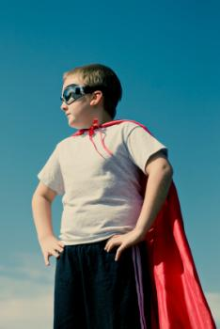
Materials: Balloons, prizes, spiders, cones, blind fold, hula hoops, foil/aluminum paper, 2 pails,
Vocabulary: musica, heroe, globos, aire, para, nombre, bolsa, mision, toca, estomago, cabeza, boca, feliz cumpleanos, piso, codo, lamiar, alfabeto, uno, obstaculo, ciego, arañas, Carrera, obstaculo, saltar, correr, cantar
Mission Blast
 | While the music is playing the little superheroes must try to keep all the balloons, or mission blast, up in the air. When the music stops they all grab one. A players name is drawn from a bag and that player must then pop their balloon and complete the challenge inside ( XXXX) to win a small prize. The music starts again and the game continues until every guest has won a prize. To make mission blast simply write out simple challenges on slips of paper and insert them into balloons before blowing them up. Challenges should be simple and fun, some examples are:
- Rub your stomach while patting your head.
- Stuff two marshmallows in your mouth and sing the happy birthday.
- Crabwalk across the floor.
- Sing your favorite song in a funny voice
- Try and lick your elbow
- Say the alphabet backwards
To play you’ll need twice as many balloons as guests. Start the game with one balloon for each guest and add one after each round. This is to ensure that the person whose name is called always has a balloon. This is a great non competitive game where everyone gets to participate.
Spidey-Sense Obstacle Course
 | Each boy gets a turn to make his way through the obstacle course and collect Spiderman’s spiders without knocking over any cones. The trick is he has to do it blind folded with only his fellow superhero trainees guiding him through with their voices.
- To play this game you’ll need to set up some barriers (cones, cushions, boxes) in the play zone. You’ll also need to purchase some toy spiders and spread them through the play zone also. Blind fold one player at a time, making sure he cannot peak. The other players can use their voices to guide him around the barriers and obstacle to find the spiders.
- You can play without keeping score or you can give each player 1-2 minutes to collect as many spiders as they can without knocking over any barriers.

X-Ray Vision
The superheroes practice their x-ray vision skills by reaching into mystery bags and trying to guess what the objects are by touch only. This superhero game is as simple as filling some brown paper lunch bags with different household objects or even food such as popcorn, an apple cut in half, broccoli florets. Use your imagination and you’ll come up with all kinds of things.

Super-Duper Obstacle Course
The little superheroes practice their superhero skills with a super-duper obstacle course games. The course can be created from all kinds of household objects. You can even mix in mini-games through out the course. Some fun ideas for obstacles are can be:
- Running through hula hoops
- Jumping on a pile of cushions or pillows.
- Have them limbo.
- Shoot a rocket through a hoop or a target. (find cheap rocket guns at the dollar store)
- Pop a balloon
- Karate chop a bad guy ( you can use a cushion or bop bag for the villain)
- Climb through a tunnel.
- Weave in and out of cones ( cones can be anything)
- Bust through a wall. Stack up cardboard boxes to make wall.- Spin around on a bat.
Let your imagination run wild and set the course up however you want with whatever you’ve got. You can play for best time or just let them run through the games and obstacles for fun. Award prizes for all kids when they’ve reached the finish.
Kryptonite Disposer Race
Kryptonite is poison to superhero powers. In this superhero game the little superheroes break into two teams and race to remove all the pieces of kryptonite without touching them with their hands. To make kryptonite, ball up aluminum foil and paint them green.
- To Play: Divide guests into two teams and have them form a line. Provide each team with two dowel sticks and enough kryptonite balls for every player, maybe two for every player. On the other end of the party space place two baskets ( buckets, boxes, laundry baskets will all work) On the start of go one member from each team use their krypto sticks(dowel stick) to grip the kryptonite balls and run them over to their teams bucket. They run back and pass the krypto sticks to the next player. The race continues until one team gets all their kryptonite into the basket.
- For younger children: you can play a non competitive version of these games where they all work as one team to remove the kryptonite. You can also use large plastic shovels instead of sticks for them to pick the kryptonite up with.

- To Infinity and Beyond
Materials: alien mask, balloons, hula hoops, beach balls, aluminum paper, “martian rocks”,
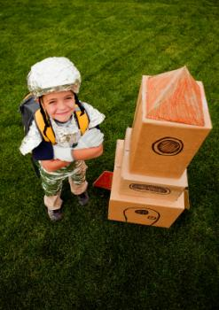
Planets and stars and red dwarves, oh my! What child isn't intrigued by the wonders of the universe? A day of science-based activities that will teach your campers about the solar system.
Watch Out with the Alien !
Split the children into pairs, and give each duo two sheets of long paper. The campers will trace the outline of their partners with crayons. When the drawings are complete, the children will use art materials to create an alien. Encourage each child to give their creation a name and a story.
Don't Drop the Android!
In this outer space theme party game the little space explorers must keep all the asteroids (balloons) up in the air while the music is playing. When the music stops they all grab an asteroid and you call out a color. Whoever has that colored asteroid must pop it and complete the challenge inside to win a prize. The game continues until all Explorers have received a prize.
You’ll need balloons of all different colors, and challenges to put inside them before you blow them up.
Challenges should be simple such as
- Do the moon walk across the floor
- Sing your favorite song in a funny voice
- Say your abc’s backward
- Stuff marshmallows in your mouth and sing happy birthday
- Pat your head while rubbing your stomach
Catch the Alien!
This is a perfect game for your space theme party. I think it makes a fun twist on the ol’ pinata. You or another fun-spirited adult puts on a Green Alien mask and the explorers must try and catch it with their space wranglers (hula hoops). When the alien is lassoed he throws out a handful of theme candy for his release. We like to think of this game as a pinata, but a lot more fun! This game continues until all the candy is gone.
You can usually find hula hoops at the local dollar store. As an alternative to hula hoops you can create laser sticks out of rolled up aluminum foil and simply have the kids tag the alien with them. You’ll also need a fun alien mask (make yourself or check out the one below) and a bag of candy
Solar System Challenge
In this outer space party theme game the explorers must collect all the planets in our solar system( plus Pluto) and rush them back to their teams star keepers. They then must put them in the correct order to win the game. This game can be played as two teams or one big team for a non competitive version.
You can make the planets, or simply print them out on card stock. Hide two sets of planets around the playing area. Teams are only allowed to pick up one of each planet. Provide a posterboard for each team to tape their planets on.
Ring Saturn
The little explorers have a blast trying to ring Saturn. Set up a beach ball as the planet Saturn and challenge the kids to toss a hula hoop and try and ring Saturn. Let them try from different distances to add to this theme challenge.
Outer Space Obstacle Course
The outer space explorers will have a blast making their way through an outer space obstacle course. Obstacles can be created from anything, all you need is a little imagination. You can even include some fun mini-games as an obstacle.
Some fun ideas for obstacles are.
- Running through hula hoops - Jumping on a pile of cushions or pillows. - Have them limbo. - Shoot a rocket through a hoop or a target. (find cheap rocket guns at the dollar store) - Pop a balloon - Karate chop an envader( you can use a cushion or bop bag for the envader) - Climb through a tunnel. - Weave in and out of cones ( cones can be anything) - Bust through a wall. Stack up cardboard boxes to make wall. - Put their head on a bat and spin around it.
Martian Rock Scramble!
In this theme game the outer space explorers must try to collect as many Martian rocks as they can and race them back to their ship, but they must beware of the Martian. The Martian is guarding the Martian rocks and if he tags an explorer they must drop any Martian rocks they have and run back to their space shuttles. When all the rocks have been collected the explorers can open them up and share the prizes inside.
You’ll need an adult Martian volunteer, a bag of candy, and Martian rocks. Martian rocks can be made by wrapping a piece of candy or small prize in aluminum foil.
To play have the Martian stand in the middle of the playing area surrounded by the Martian rocks. The little explorers wait on either side until the word GO. Their shuttle can be a basket or bucket to collect their rocks in.
Rocket Shuttle Landing
Hang a hula hoop from the ceiling and provide all the guests with paper to make their own paper shuttles or airplanes. They then practice flying their shuttles by trying to fly them through the hoop. They can start close and get farther and farther away.

- Tasty Science

How to Make a Lunar Crater
http://www.jpl.nasa.gov/edu/teach/activity/make-a-crater/

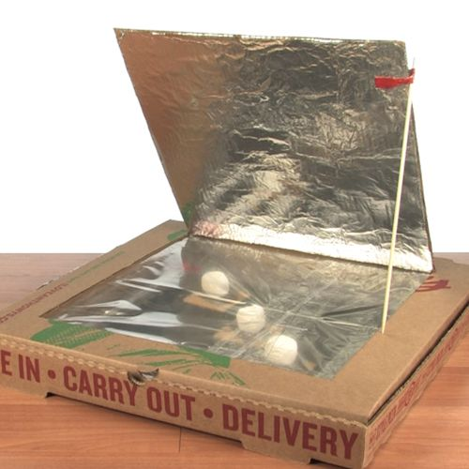
Making Sun S’mores

http://www.stevespanglerscience.com/lab/experiments/solar-oven/

EXPERIMENT MATERIALS
- Pizza box
- Two clear sheet protectors
- Black construction paper
- Duct tape
- Clear masking or packing tape
- Box knife
- Scissors
- Thermometer (optional)
- Wooden skewer
- Glue stick (Elmer's glue will work, too)
- Tin foil
- Ruler
- Pen
INSTRUCTIONS
- On the lid of a pizza box, use a ruler and pen to measure and draw a square that is 1-2″ from the sides of the box.
- Cut along three sides of the square you just made by using box cutters or a pair of scissors.
- Measure and cut a large piece of foil to line the bottom of the pizza box.
- Apply glue to the bottom of the pizza box and glue the large piece of foil into place, smoothing in down.
- Measure and cut another large piece of foil to cover the bottom of the flap you cut on the pizza box lid.
- Apply glue to the bottom of the pizza box lid and glue the tin foil piece into place.
- Use scissors to cut a piece of black construction paper that is 1-2″ smaller at each edge than the bottom of the pizza box.
- Use clear masking or packing tape to tape the black construction paper to the bottom of the pizza box. Try to center the black construction paper.
- Find a sheet protector and pull the two pieces apart. Tape these pieces together at one of their long edges. Tape the new, large piece of plastic on the inside of the box lid, NOT the flap. The plastic should span the flap opening. If it doesn't, make a larger plastic sheet!
- Use a wooden skewer to poke two small holes (don't poke the skewer all the way through) on the lid between the flap and the side of the lid. Poke the holes about 2″ apart.
- Wrap a thin piece of tape around the skewer, near the flat end, so that one end of the tape is above the other end. Check out the photo at the right to see exactly how to wrap the tape.
- Tape the skewer to the flap so that the flat end of the skewer is near the end of the flap. Use the skewer and the holes you poked in the lid as a kickstand for the flap.
- If you want to see just how hot your Solar Oven gets, tape a thermometer to the bottom of the box so that it can be seen through the plastic window.
- Set up your oven with the flap up and place it in the sun. It may take a little while, but you'll watch your s'mores heat up, melt, and be ready to eat!

Home made Ice Cream

EXPERIMENT MATERIALS
- Large, plastic container (or large coffee can) with a wide-mouth opening, gallon-sized (3.77 l)
- 2, quart-sized (1 l), zipper-lock bags
- 5 pounds (2.3 kg) crushed ice
- 1 pound (453 g) rock salt
- 1 pt (473 ml) half & half cream
- Vanilla extract, small bottle,
- 1 pound (453 g) granulated sugar
- Measuring cups and spoons
- Cloth towel (or winter gloves)

EXPERIMENT
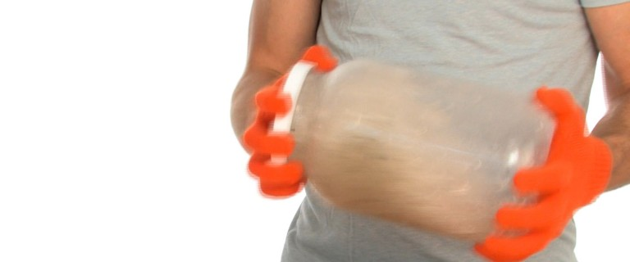

1
Fill the container about half-full with crushed ice. Add about 6 T of rock salt to the ice. Seal it and shake the ice and salt combo for about five minutes. You’ll need to wear your gloves when you’re handling the jar. If you’re curious as to why you should wear gloves, a thermometer in the ice will explain it. The salt and ice mixture gets down to about 14℉ (-10℃)!
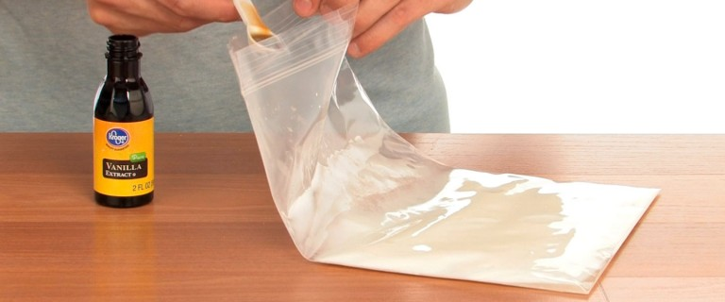

2
Mix the following ingredients in one of the zipper-lock bags:
- ½ cup of half & half
- 1 T granulated sugar
- ½ tsp vanilla extract
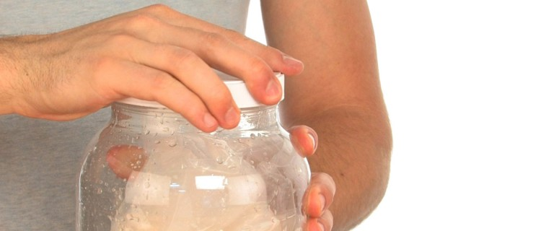

3
Push as much air out of the bag before sealing it tightly. Too much air left inside may pop the bag open during the shaking. Seal the first bag into the second bag by pushing out the air as well. By double-bagging, the risk of salt water and ice leaking into the ice cream mix is minimized. Place the two sealed bags into the ice and salt mixture. Close the container tightly.
Wrap the container in the towel or put on your gloves. Shake, rock ’n roll, and mix that container! Your ice cream should be ready after about 15-20 minutes so pace your shaking energy. Maybe get some help with an offer to share a little of your creation.
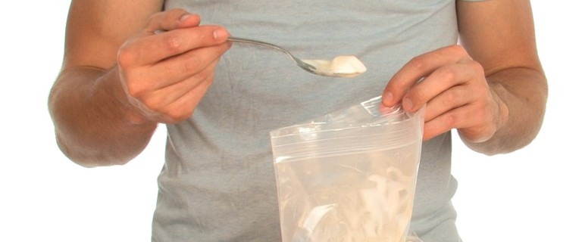

4
When your ice cream is as firm as you want it, remove the bags from the jar and rinse them off with cold water. You don’t want ice or salt water accidentally getting into your treat. Enjoy your creation right out of the bag. Store any leftovers – what are the chances?? – in a freezer. Start planning for your next batch and consider making new flavors, too. Maybe this is how Ben and Jerry got started.

Dancing Raisins
Materials for Dancing Raisins Science Activity
- raisins
- 2 clear glasses
- carbonated water and regular tap water
Procedure for Dancing Raisins Science Activity
- Pour some carbonated water into a clear glass.
- Add some raisins and watch what happens.
The raisins begin rising up to the top of the glass and then going back down again. The kids were mesmerized!
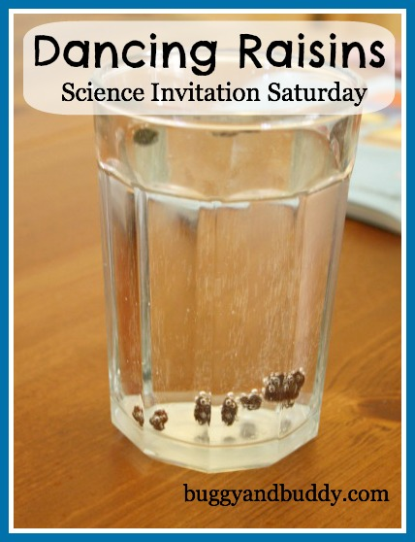

Invisible Ink

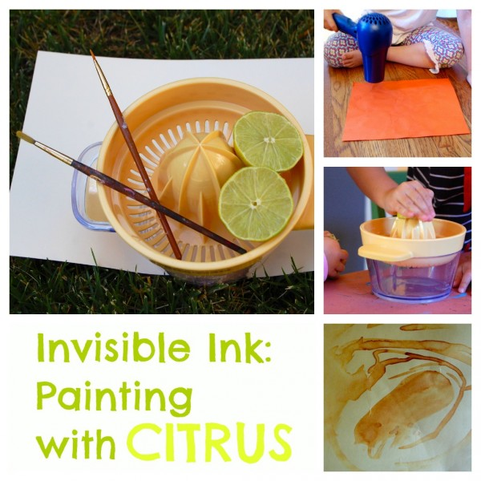
Lemon juice is acidic, and acid weakens paper. When paper is heated, the acid burns and turns brown before the paper does.
Supplies
- Lemon or Lime Juice
- Paper
- Paint brush or Q-tip
- Iron
Steps
- Squeeze lemon or lime into a bowl.
- Paint the juice onto your paper with a paint brush or Q-tip.
- Wait for the paper to dry.
- Heat the paper with an iron, hair dryer, light bulb, or other heat source. Be careful that you don't hold it there to long, as it could burn the paper.
Notes
Experiment with other liquids: milk, orange juice, white wine, vinegar, and apple juice are good bets.
Sugar Rainbow

http://www.stevespanglerscience.com/lab/experiments/sugar-rainbow/

Mentos & Soda
- A roll or box of Mentos chewy mints (stick with the standard mint flavor for now)
- 2-liter bottle of diet soda (either diet or regular soda will work for this experiment, but diet soda is not sticky when you’re cleaning it up, and it will usually create a bigger blast)
- Sheet of paper to roll into a tube
- Drop Mentos into a bottle of soda and run away from the 20 foot geyser
- It’s been called the “vinegar and baking soda” reaction for a new generation. While science teachers have been dropping candies and mints into 2-liter bottles of soda for years in an effort to release all of the dissolved carbon dioxide, the Mentos and Diet Coke reaction became world famous in 2005. Fueled by hundreds of blogs and popular online sharing sites like youtube, this once obscure reaction became an Internet sensation, and the enthusiasm for dropping Mentos into soda continues to grow. Once you get past the initial gee-whiz factor, there’s some amazing science behind a carbonated beverage and a chewy mint.
- http://www.stevespanglerscience.com/lab/experiments/original-mentos-diet-coke-geyser/
- http://www.sciencekids.co.nz/experiments/dietcokementos.html

Mad Science
Monster Slime
Creating slime is a classic mad science activity. The following slime recipe is soo cool because it flows when you pour it and it hardens when you squeeze it. It’s non-toxic and it doubles as an awesome party favor. If you choose you can even color it with food coloring. Monster Slime Ingredients
- 1/2 cup of glue
- 1 cup of liquid starch
- (optional) food coloring
The kids can create the slime using any container, but I recommend a zip-loc bag because you can make the slime inside it and then use it as storage.
1. combine the corn starch and glue together.
2. (optional) add a few drops of food coloring.
3. Using a spoon squish the ingredients together in a zip-loc bag.
Voila! Slime will last for a couple of weeks in baggie or even longer if kept in the refrigerator.
Mini Volcano’s
Your party will go down in the history of cool parties when you let each kid create their own mini volcano! It’s not nearly as complicated as it seems. You’ll need:
- An empty film canister for each child ( you can often find these for free at your local photo shop.
- A can of brown play-doh for each child. ( or you can create your own dough to save on the budget)
- 1 tablespoon of vinegar for each child’s volcano.
- 1 tablespoon of baking soda for each child’s volcano.
- 1 sturdy paper plate for each child.
- Aluminum foil
OPTIONAL INGREDIENTS:
- A can or two of red play-doh. This is just for aesthetics for the top of the volcano.
- Red food coloring – color the vinegar before use to add color to the eruption.
- Dry ice. Put a small piece of dry ice in the film canister with the baking soda. When the vinegar is added the volcano’s will actually smoke. This one really impresses the children.
Steps:
1. Give each child a film canister, paper plate covered in aluminum foil, and play-doh can. 2. Let them build a volcano form around the film canister (on top of the paper plate, making sure they have the film canister open at the top (like a hole in a volcano).
3. Once everyone has finished put the baking soda (and the dry ice if you have it) inside the film canisters.
4. Let the kids add the tablespoon of vinegar. Voila! The eruption is acid meeting another substance called an alkali
Mini Rocket's
Did you know you could make a cool rocket from a bottle, baking soda and vinegar. This experiment is a blast! The kids will not be able to do this themselves, adult supervision is required and safety glasses are recommended (we don’t want anyone’s rocket to shoot there eye out). I would explain the how to here, but this video is so much more fun!
Test Tube Relay Race
Divide players into two teams. The first person from each team races to the lab with a test tube filled with water in hand. Once at the lab ( a table set up with rest of supplies) the child will discover beakers (you can use cups if you don’t have beakers) with red colored water, another with yellow, a third with blue, and a dropper to pull the water out with. At this point the lab professor (an adult volunteer) assigns each player a color. They must use the colored water to create that color in their test tube. Once they do this they rush it back to their team and pass it to the next player. That player then empties it, fills it up with fresh water (have a bucket of plain water next to each team) and repeats the race. The first team whose member finish the race wins. Supplies you’ll need:
- Two buckets of plain water
- Two test tubes (one for each team)
- Two cups or beakers full of red colored water
- Two cups or beakers full of yellow colored water
- Two cups or beakers full of blue colored water
- Two droppers
- Two lab tables (the lab should be set up on the other side of the playing area.
Manic Static
This game let’s kids see what cool things they can do with static electricity. Give each child a balloon and have them rub it on their hair until their hair stands up. NOTE: if the child hair does not produce static, let them rub a wool cloth on the balloon instead. Next let them try these fun experiments.
- Tie another balloon to a string and tape the other side of the string to the ceiling. Let the children take turns moving the hanging balloon with the static from their balloon.
- Put out a couple of empty soda cans and let the children see if their static balloons can move them.
- Turn on the faucet so that the water runs in a small, steady stream. Rub the balloon on your head a few times, then move it near the water. The stream will bend without being touched.
- Put a teaspoon of salt and paper on a plate for each child. Grains of salt and pepper will react toward their balloons by jumping on them .

DIY LAVA LAMP EXPERIMENT
Get ready for crazy fun - this guy shows you how to make a "lava lamp" like show using a 2 liter bottle, water, vegetable oil, alka seltzer, and food coloring.
- Start by pouring 3/4 cup of water into the bottle. You may want to use a funnel to make this easier and less messy.
- Next pour the vegetable oil into the bottle until it's almost full. Give it a few minutes and let the water and oil separate.
- Add ten drops of red food coloring to the bottle (any color will work actually).
- Now for the exciting part - I would tell you but the video is so much more fun!

6. PIRATE DAY
Errrr matey - hoist me black and white flag and prepare to set sail as we voyage across the YPWsibbean. Adventure awaits us in every port where "X" marks the spot and buried treasure is within our reach. Be ye a pirate or be ye a princess, show your spirit by wearing your favorite costume. Shiver me timbers! And, don’t forget your tiara or eye patch.

TICK TOCK! CATCH THE CROC CLOCK
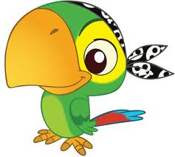 | For this party game you’ll need a kitchen timer. The kind the you turn and it ticks until the timer goes off the it RRRRings. To play the game simply set the timer for one or two mintes and hide it around your playing area. The crew must find it before it goes off. The first person to hide it can be the next to hide it.

WALK THE PLANK
Create a plank out of a board and have the crew practice walking the plank. See if the can do it sideways, backward, blindfolded, etc. You can also consider a relay race where you have two planks and each player must walk across the plank, pick up a bucket and return it to their team without losing their balance.

CAPTAIN HOOK'S TREASURE FISHING
Purchase a few Pirate Hooks and have the kids use them to scoop up small prizes from a kiddie pool filled with water . Before the party starts, add a wire loop to each item. Let each kid take a turn hooking a prize.

CANNONBALL FLOAT
Don’t let the cannonball touch the ground! In this timeless and simple game players work as a team to keep the black cannonball (balloon) up in the air. If it touches the floor everyone yells “hit the DECK!” and dives on the ground to take cover. It’s fun and silly. Play as many rounds as you want.

TREASURE DIG
Another game you can play with a kiddie pool is treasure dig. You can fill the pool with dirt or shredded paper if it is an indoor party (or you just don’t want to deal with dirt ) Hide pennies or plastic gold coins inside for the kids to find. Play it like a relay race where a child from each team must find ONE coin, rush it back to their team and tag the next player. At the end of a ,say, 5 minutes whichever team has the most coins win!

7. TOTALLY GROSS
Spaghetti Toes
Fill a bucket or small tub full of cooked spaghetti and mix in some plastic bugs. Plastic roaches work the best. If you want to really up the ick factor go ahead and add in the spaghetti sauce.
TO PLAY: Have kids remove their socks and shoes. Give them each one minute to pick as many bugs out of the bucket using ONLY their feet and toes. Award prizes to whoever grabs the most. Have towels ready for cleanup.
Spit Ball Competition
Yea, this one’s totally gross! Divide the players into two teams. For each team inflate a balloon and draw a happy face on it for good measure. These are their targets. Each player is given a straw and each team is provided with a roll or two of toilet paper. Give a quick lesson on how to make a spit ball and then let the challenge begin. Players have five minutes to create and spit as many spitballs as they can at their balloon head. The team who sticks the most at the end of the five minutes is crowned victorious! Hey I warned you it was gross, needless to say this is a game to play outside.
Dirty Diaper Scavenger Hunt
Purchase a pack of newborn diaper (they provide the most diapers for the price) and open and fold them up like you would a dirty diaper. In one of the diapers include a candy bar (wrapper removed of course, you could even melt it a little first if you want it to up the gross factor). Hide the diapers all around the playing area. When you are ready to play challenge the players to find the diapers and announce they will need to open them because one holds a special surprise. Award a prize to whoever finds the most diapers and another prize to whoever find the surprise diaper.

Slime Time!
Of course what gross out party would be complete without slime? This is a fun activity that doubles as a cool party favor that the kids can take home. Make a practice batch before the party just so you feel prepared during the activity.
WHAT YOU’LL NEED
- Box of Borax. You can find this in the same aisle as laundry detergent
- 3 bottles of Elmers Glue
- Distilled water
- Food Coloring
- Ziploc bag for each child
- Small plastic containers. One for each guest to make and store their slime
HOW TO MAKE
- In a large jug mix together glue and equal parts distilled water.
- Give each guest a container and Ziploc bag.
- In each Ziploc bag add two tablespoons of the glue water, then zip shut the bag.
- In container have kids add water to two generous tablespoons of borax until the borax becomes more solid.
- Next, they will add the borax mixture into the Ziploc bag with the glue water. Shut the bag again and mush it together with their hands to create the slime.
- If the slime is too stiff add more glue water. If it is too runny add more of the borax mixture.
- Now let the kids add a few drops of the food coloring of their choice to tint the slime. Finished!
- When the kids are done playing with it store in clean, dry, containers.
Feast of Worms
WARNING: This one is MESSY!
Sit all the players around the table. For each kid place a few gummy worms on a paper plate and cover with chocolate pudding. The challenge is to be the first to eat all the gummy worms with their hands behind their back. Faces will be COVERED in chocolate mess so have plenty of towels ready and take plenty of pictures.

8. INTERNATIONAL SPY HUNTER

LASER CHALLENGE
 | You see it in every spy movie. The spy or secret agent must make their way through a maze of criss-crossed lasers that will sound the alarm and ruin the mission with the slightest touched. To create your own version of this game you will need yarn and mini bells (often found at the dollar store).
Set aside an area to set up this game. You will string the yard around as the lasers. On each yarn laser attach a mini bell. Criss-cross the yarn so that players will need to crawl under, over, up, and down to make it through the lasers. Set up an object at one end of the yarn obstacle. Start the players off on the other end. The object is to make it through the lasers, retrieve the object, and come back without ringing the bells. Start each player off with ten points and let each try it one at a time. Every time the make a bell ring they lose a point. The player with the most points at the end wins.

FINGERPRINT MATCH
For this game you will need one index card for each player. The index cards need to be cut in half. Using an ink pad let each child put a print of the same finger on each card. Divide the players into two even teams. Collect all the fingerprint cards from each team (keeping them separated).
Hand each team the other teams set of fingerprint cards. These should be scrambled together so the identical sets aren’t all together. On the start of go each team must pair the fingerprint cards together with their match. The first team that matches all fingerprints correctly wins.

MASTER OF DISGUISE RELAY
You will need a collection of fun and silly costume props, hats, sunglasses, mustaches, etc. You can find these items at the dollar store, thrift stores, or perhaps even in the basement.
Divide players into two teams, and divide costumes up into two different suitcases. If you don’t have two suit cases use a brown paper bag or similar. Have the teams line up one side of the playing area and have the suitcases (or costume bags) waiting at the other end. On the start of go one player from each team must race to the suitcase, take out a top, a bottom and three other costume items (this could be a hat, sunglasses, and a fake moustache) and put them on. Then they race back to their team and take off all the items and pass them to the next player. That player then puts on all of the items and races back to the suitcase and switches them all out for a new disguise combination. This continues until the last player has changed costumes and made it back to the team.

FIND THE BOMB
For this you’ll need to make some dynamite sticks. You can do this simply by wrapping five paper towel rolls or paint rolls with red tissue paper (construction paper works also). Tape all of them into a bundle using black electrical tape. If you have spare wires or coils you can add those to up the cool factor.
The most important element is a kitchen timer or similar. This needs to be one that actually make a slight ticking sound works the best. Tape this onto your dynamite creation as well.
To play the game wind up the timer and hide the dynamite. Tell the players their training mission is to retrieve the bomb before it goes off.

BOMB STOMP
Inflate a bunch of black balloons then create a “fuse” for them by tying a long piece of twine on each balloon and taping a piece of orange or red colored tissue paper (this is the lit part of the fuse) to the end of each piece of twine.
Put them all together in a room and have the players rush to diffuse the bomb (pop them) as fast as possible. This game is even more fun if played to some Mission Impossible music.

OBSTACLE COURSE
Set up different obstacles for players to run through. You can play for best time or just for fun. You can create the obstacles from anything, some ideas include:
- Climbing through objects such as old tires or appliance box.
- Having to dig something out of a kiddie pool before moving to the next obstacle.
- rent an obstacle course bounce house
- zig-zag through cones.
- throw something through a hula hoop hanging from a tree.
- spin around in a circle and try to walk a balance beam (2x4 board)
- Use a water gun to shoot a balloon across a distance
- Do jumping jacks, sit-ups, or push-up.

GUILTY PARTY
Guilty Party This spy training game is a great way to test the players body language skills. In the middle of the room is an diamond ring - plastic one of course.
One player leaves the room. One player in the room must swipe the ring. The first person comes back in and has three chances (this of course can be changed depending on how many players you have) to guess who has the ring. If they guess correctly they win a prize. The thief is the next person to leave the room.
- Hai – Ya! Ninja Day
No Hands Scrolling
For this activity you will need a roll of paper cut into strips, paint brushes, and paint. Have the children take their shoes and socks off. Each child has to put a paintbrush between their toes and try to paint their name on the “scroll”. If the name is legible then receive the next color of belt.
Keep'em Up
You will need to purchase some cheap foam swords or make them from 260q animal balloons. You will also need a small bag of latex balloons and inflate them with air. Each child will need a balloon and a sword. On go, the children are to put the balloon in the air and keep it off the floor using the ninja sword. The longest to keep the balloon up wins a prize. Each child can now receive the next belt.
Ninja Star Toss
This can used as an activity and a ninja game. You can have the children make origami ninja stars or you can cut out paper ones. Have a bucket or large bowl available and a timer set for 1 minute. Each child will stand 3 to 5 feet from the bucket and attempt to toss as many ninja stars into the bucket in one minute. The ninja with the most in wins. If there is a tie, they will compete until there is a winner. Once, complete they receive their next belt.
Hai-Ya!﻿
You will need one helium filled balloon on a string for each child attending the party. Tape the balloons to the floor several feet apart. You can draw a ninja mask on each balloon to add character. The mission is to see if the little ninjas call kick the balloon ninja in the head or face but they have to say Hai-Ya!, or that attempt doesn’t count. This will lead to many laughs and a great photo opportunity. Now they are one step closer to being a ninja.
Chopstick Pick
The supplies for this theme are; chopsticks, a timer and a bucket. Have the children get into teams and hand each child a pair of chopsticks. Put several small objects, such as a marshmallow, cotton ball, a fake fly, marbles…etc., on a table in front of each group. The idea of the game is to pick up as many objects as possible with the chopsticks and put them in their teams’ basket. The team with the most objects by the time 2 minutes is up, wins.
Hide and Go Seek
Have the children take turns being the ninja master and the others, infiltrators of the shrine. This is played just like hide and seek. The ninja master counts while the others hide. Once an infiltrator is found, they become the ninja master and have to count while others hide.
Chopstick Relay
Have the children pair up with a partner. Give each pair a small marshmallow and a pair of chopsticks. The purpose of the game is to work together. Each child will hold one chopstick and work together to pick up the marshmallow and take it across the room or yard and back without dropping it. This game requires a lot of patience and team work. When completed they receive the next color of belt and they are well on their way to becoming ninjas.
Moves Like Master
This game will require a good ear. A parent can play the Master or a child can be chosen. The master will stand in front of the group and make different ninja stances. They will say “Moves like Ninja Master and change stance. Occasionally, forgetting to say Ninja. Anyone who changes stance when Ninja is not said is out. Last one remaining is the Master Ninja. Everyone receives the next color of belt.
Tuck & Duck
This is a fun game that can also be considered exercise. You can use crepe streamer or string. Run the string/crepe from one side of the room to the other, running them in different directions, at different heights. Then run a line in front of it for the children to use as a balance beam. And the very end put the black belts. The little ninjas will have to get through the maze of strings by tucking and ducking. They have to make it through the strings without touching them or tearing them down. Once completed, they will walk the line without “falling” off and if done without error they get their black belt.
Hidden Ninjas
Cut out several little ninjas, about two inches tall each. Hide them all over the party area. As the children enjoy games and activities they are on the hunt for the ninjas. The child with the most ninjas at the end of the party gets a special prize.

- Fiesta

SOMBRERO DANCE
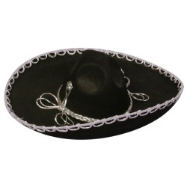 | In this fiesta game if you get caught with the sombrero you must eat a hot pepper!  To play you’ll need a sombrero, music, fun loving players, and chili peppers. As your dancing to some festive music take the sombrero and place it on somebody else’s head, they then must place it on another’s head, and so on.  When the music stops whoever last had the sombrero on must eat a pepper!

TACO BATTLE
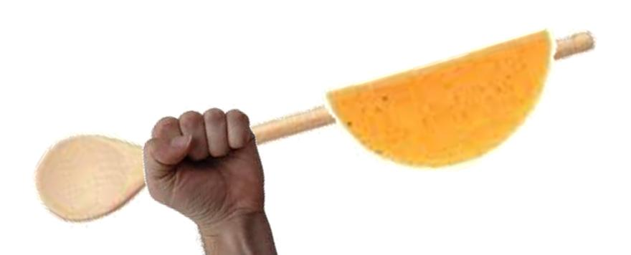 | Two people will face off in a taco battle. This game is best played outside so as not to get taco shell all over your house. Mark of boundaries for the battle field, usually a 5-6 ft circle. Both contestants enter the battle ring wielding a wooden spoon with a hard taco shell balanced on it.  The rules are simple; both players must try to break the other person’s taco shell while at the same time protecting theirs from breaking or falling.  You are not allowed to touch hit, kick, push or pull the other person, only their taco sticks or tacos. The last taco shell intact wins.

MEXICAN PIñATA
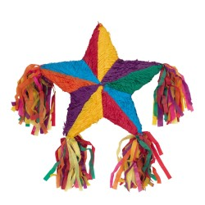 | What could be more perfect at a Mexican fiesta than a piñata. Get creative with what you stuff your piñata with, who said they had to be stuffed with candy? Hang it from a tree and let the fun begin. Play the traditional way by blindfolding each player, spinning them around three times, and then handing them a bat or stick in which they can swing three times to try and hit the piñata.  Once somebody breaks the piñata and all the treats fall out it is a free for all for everyone to grab as many as they can.
If blindfolded people swinging bats is too much of a walk on the wild side for you, try using a pull string piñata instead. With this style of piñata each player takes turns pulling ribbons from the bottom until the ribbon that is attached to the trapdoor is pulled releasing all the goodies inside.

MACHO NACHO CONTEST
Divide players into pairs. One person from each team is “the eater”, they must stand with their hands behind their back in front of their bowl of nachos. The other player is “the arms”, they stand behind their partner and serve as their arms.  On the start of go “the arms” must feed the nachos to “the eater”. The first team that finishes their bowl wins. Be forewarned this game is quite messy, but hilarious fun! | 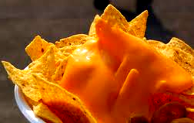
ANOTHER VERSION With their hands behind their backs, each contestant will dive face first into a bowl full of messy cheesy nachos. At the bottom of the bowl are three peppers. The first person to retrieve all their peppers wins! Make sure you have a camera, because you’re going to want to get lots of pics.

MEXICAN KICK BALL
This is a fun relay race that is a traditional game in Mexican villages. Divide into two teams, one person from each team starts and kick a ball through an obstacle course as fast as they can. After they finish they may pick up the ball and run it back to their team to pass it to the next player. The first team whose members fully complete the course is the winner. Ideas for obstacle could be kicking:
- through a tunnel  - around a tree  - in and out of cones or logs | - under tables or chairs  - over a low net  - backwards

BEAN RACE
To play this game you’ll need a big bag of DRY pinto beans and enough drinking straws and plastic cups for each player to have one. Pour all the beans onto the table. On the start of go each player must use their straws to suck a bean onto and rush it over to their cup without dropping it.
The object of the game is to collect as many pinto beans as you can in your cup, without touching them with their hands. Set the clock for 3 minutes. Have their cups lined up at another table to make the challenge harder (and funnier).
- Can You Handle the Pressure?
Come and join us, for a journey into the realm of pressure. When you combine one part technology and two parts imagination with some household knowledge and a little dirt, the outcome is some excitingly unusual activities, games and experiments that are sure to capture your attention and make you say WOW!
- Crazy Lego Robotics Day
Who doesn’t love Legos? At YPW Spanish Camp, we LOVE them, and thought it would be the best idea to have a Lego robotic day to build and program your own robot! Campers will have an opportunity to learn, build and explore utilizing LEGO® bricks. This day provides an extraordinary atmosphere for kids of all ages to build unique creations, play games, and have a lot of fun.

http://www.queen-of-theme-party-games.com/gross-party.html

