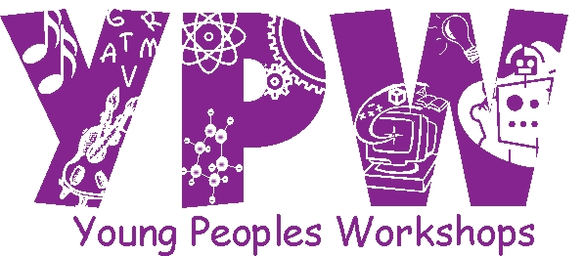

Teacher Lead Activities
Circle Time | language Development | Literacy & Writing | Math and Manipulatives | Science And Discovery
~ Greetings  ~ Job Chart  ~ Calendar  ~ Days of the Week Song  ~ Read a Letter Ww book  ~ Create Ww word list(Tues)  ~ Sing “Where Do You  Start Your Letters?”  ~ Identify Rectangles around the classroom | “Por Un Estornudo” “Because of a Sneeze” : Cause and Effect and Predictability  Helpful Olivia is cleaning the furniture while little mouse watches from its hole under the table. But what happens to all the dust? It goes into Olivia’s nose making her sneeze! What will happen now? | Arrival Time: children will practice writing their own name  ~ Letter Ff: Practice writing the letter and awareness of its sound.  ~Creating a letter Ff word list  ~ Journal Writing: My silly pumpkin face | ~ Making Leaves pattern  ~ Sorting pumpkin seeds by their size  ~ Rubber Ducks: students will roll a dice then count the dots and place the corresponding number of ducks in the “pond”  ~ Stimate game: How many leaves in the plate? We will graph student’s answers | ~ Exterior Molds: clay  impressions of dinosaurs to create fossils  ~ Chemical Reaction: Mentos and Diet Coke
Art | Music /Movement | Outdoor Activities | Vocabulary
~ Mr. Pumpkin Head: Children will fill a paper pumpkin with orange mosaics  ~ Painting Leaves: Students will pick a real leave to decorate it with various materials.  ~Tracing Stencils | We will dance “Las Cinco Calabazas” with colorful scarves | ~ Sidewalk Chalk  ~ Dress Ups  ~ Hula Hoops | Las Estaciones, el otoño, hojas, frio, calor, naranja, café, sueter, botas, bufanda  Rectangulo
Value
Children will make thank you notes to their parents for all the love, caring, toys, food they receive from them. Children will make suggestions to add to the thank you note.
Enrichment Activities  Friday : Yoga with Maestra Julieta. Parents don’t forget to send your children with comfortable clothes  Monday: Chiquitos Workshop  Thursday & Fridays: Art Workshop : The Art of Frida Khalo. Children will be making self – portraits following the style of Frida Khalo.  Tuesday & Wednesday : KUMON | Special Projects / Activities  ~ Thursday and Friday a policeman will visit the children to talk about “stranger danger”  ~ Monday and Wednesday Parent Conference  ~ Family Project : Mexican Frame

Interests observed or Skill  Desired | Action Taken  In Classroom | Developmental  Benefits
Students are talking about the cold weather.  Students are not sharing with their friends. | Students will understand the meaning of fall.  Students will make various crafts and bake cookies to share with friends and neighbors. | Students will learn about the seasons, we will be focusing on fall, on why the leaves fall and change color. What does autumn means, when does it start. This will give the children a better understanding on weather and its changes.  ~ Phonemic Awareness  ~ Adopting the “I Can Do It” attitude, sense of  accomplishment and follow through on tasks.  One-to-One correspondence is a foundational math skill for preschoolers. It can take months or even an entire school year for preschoolers to master this skill. For this reason it is important to provide our students with plenty of opportunities to practice one-to-one all year long
FOCUS
~ Introduce the letter Ww: writing it, reading it, learning
its sound
~ Self Help Skills: opening own containers, putting own socks
and shoes on, Mat Jobs
~ Use one-to-one correspondence to solve problems by matching sets and comparing number amounts and in counting objects to 10 and beyond and to recognize the number of objects in small groups without counting and by counting.
Sensory Development: Hang new pictures, eye level. Collect smooth and rough stones or rocks. Post posters of Senses talk about seeing touching and tasting real food.
Science and Discovery: Rough and smooth rocks with magnify glass
Manipulatives: blocks,puzzles
Art: magazines, greetings cards, leaves,
Sensory Table: Oatmeal with various items: bugs, containers, tongs, scoopers
Large group activity: Pumpkin face art
Dramatic Play: Setup pretend Juice bar. Baskets of pretend food. Laminated pictures of kitchen scenes, café, restaurants, cooking appliances.
Outside: Hoola Hoops, Balls different sizes
Language/Literature: List of Books

