January 15th, 2020

To Whom It May Concern:

I am writing to encourage you to accept Jennifer Pelaez González into your school’s dual language Pre-kindergarten class.
She is ready, both socially and academically. Jennifer has been a student at YPW Spanish Immersion School. She is a bright, happy girl who loves to participate in class and plays well with others. Jennifer knows to respect authority and school property, knows how to pick up after herself and is patiently able to wait for her turn in line.
Jennifer transitions easily from one activity to the next. She is a wonderful listener and always follows directions. Jennifer always makes sure that her work is neat and finished in a timely fashion.
I am confident that Jennifer Pelaez González is a natural learner who will embrace the challenges in your program.

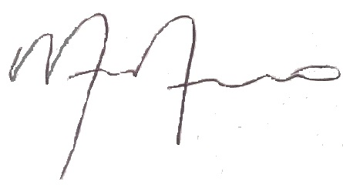
Sincerely,

Monica Moreno
YPW General Director

