March 10th, 2021

To Whom It May Concern:

I am writing to encourage you to accept Scout McKnight into your school’s kindergarten dual language class.
She is ready, both socially and academically. Scout is a student in my kindergarten class. She is smart, sweet, and social. An enthusiastic student, quick to grasp new concepts and apply them to “real life”.
She is well-prepared for kindergarten, with an understanding of how words are formed. She can write all the letters and numbers legibly. Scout also understands basic math concept can count to 100.
Scout is an outgoing child, with many friends. She is pleasant to be around and quite polite and mature, especially for a 5-year-old. She follows class rules without hesitation and is respectful of his peers.
I am confident that Scout McKnight is a natural learner who will embrace the challenges in your program.

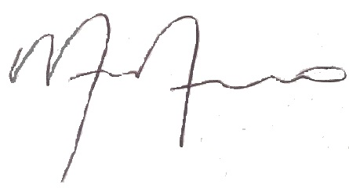
Sincerely,

Monica Moreno
YPW General Director

