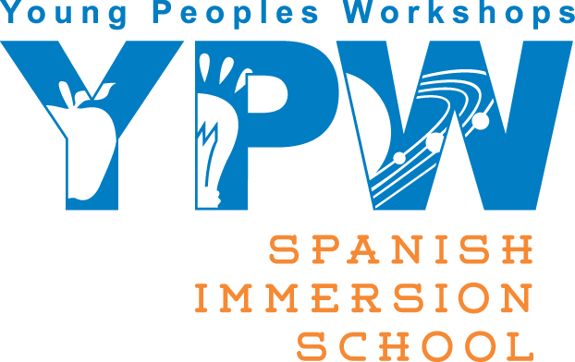
3640 Bee Caves Rd, Austin TX 78746 512.329.5611 fax: 512-366-9333 www.YPWkids.com

Re: Donation for Teacher / Staff Appreciation Dinner
Dear Sir/Madam,
The parents at YPW Spanish Immersion School are planning our annual Teacher/Staff End Year Awards to be held on mid May.
As the general director of YPW Spanish Immersion School, I feel very blessed to have such a wonderful group of teachers. Every teacher is an asset to our school and the parents and students are privileged to be a part of this.
Staring this year, we would like to honor our schools hard working, dedicated teachers and their outstanding support staff with a dinner and prizes. The dinner will be provided by our parents and for the prizes we are asking for your help.
Will you join our families in giving our teachers a big Thank You! We are asking area busineess to donate an item or gift certificate that we can use as a prize. If you are interested, you may contact the school at 512-329-5611 and ask for either Laura or Ligia or feel free to contact myself at 512-417-3711
We will happy to pick up your donation and you will also receive a thank you from us with the name of the teacher(s) who receive your donation.

Many Thanks!
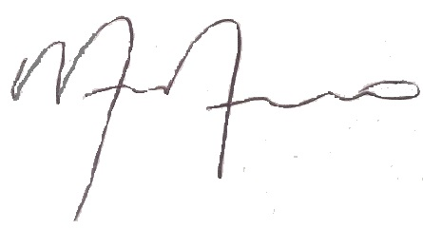

Monica Moreno
YPW General Director

