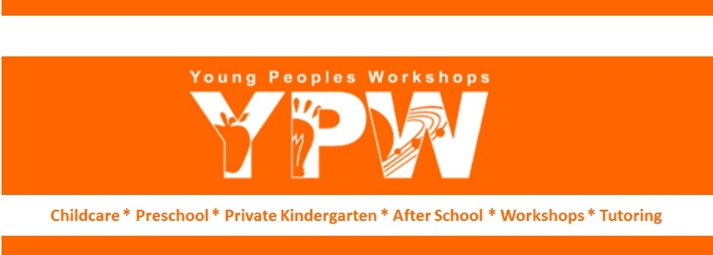

2021 New Year Workday / Training Agenda
Location: YPW Westlake / Remote & In Person
Date: Monday, January 4th, 2021 from 8:30 am to 5:30 pm

- Happy New Year!
- Leadership team must be at school all training day.
- Training / Meeting from 8:30 to 1:00 pm via Zoom. Teachers can participate from home or school. From 2 to 4:30 pm classroom/school organization and cleaning. Teachers need to be at YPW. from 4:30 to 5:30 teachers can be at school or home to finalize training.

- 8:30 am to 9:30 monthly meeting via Zoom. Monica Moreno
  - Zoom Info => Meeting ID: TBD Passcode: TBD
- 9:30 – 10:00
  - Review - Preventing and Controlling COVID-19 => 30 min - Laura Capetillo
- 10:00 – 10:15 Break
- 10:15 to 1:00 pm Mandatory Annual Training - Laura Capetillo
  - Emergency Preparedness => 30 min
  - Preventing and Controlling the Spread of Communicable Diseases, including Immunizations => 60 min
  - Administering Medication => 15 min -
  - Preventing and responding to emergencies due to food or an allergic reaction => 30 min
  - Understanding building and physical premises safety, including identification and protection from hazards that can cause bodily injury, such as electrical hazards, bodies of water, and vehicle traffic => 30 min

- 1:00 – 2:00 pm Lunch / Traveling to YPW

- 2:00 – 4:30 pm Classroom/Office organization, deep cleaning, planning time
  - Leadership team go over these two checklists:
    - Office:
https://www.ypwkids.com/wp-content/uploads/2013/04/ClassroomSetup.pdf
- Teachers:
https://www.ypwkids.com/wpcontent/uploads/2013/04/EndBeginning_oftheYearCleaningChecklist.pdf
  - Deep cleaning moving furniture – Sanitize EVERYTHING –
    - Rotate material in Centers
    - All material in centers complete and clean
    - No broken material in any center (pay special attention to Art Center)
    - Replace damaged labels
    - Bulletin boards updated and ready
    - Clean / sanitize common areas
    - Library
    - Staff room
    - Kitchen
    - Lobby
    - Material room
    - All Playground equipment and areas
  - New students paperwork and cubbies with label
    - Updated allergy list
    - Update emergency
  - Extra time? Catch up with lesson plans

- 4:30 – 5:30 pm Handling, storing, and disposing of hazardous material => 60 min
    - To do at home: Instruct teachers to study this at home. They must pass a quiz to complete this training.
    - https://www.ypwkids.com/wpcontent/uploads/Training/BloodBorne_Training.pdf

